CPK Chicken Tequila Fettuccine
Prep Time 15 minutes Cook Time 20 minutes
8 Servings

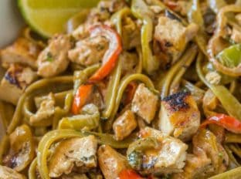
Ingredients
2 Tbsp garlic minced
2 Tbsp jalapeños minced
3 Tbsp unsalted butter
¾ cup chicken stock
2 Tbsp tequila
2 Tbsp lime juice
1 ½ cups heavy cream
3 Tbsp soy sauce
2 Tbsp vegetable oil
4 chicken breasts
¼ tsp kosher salt
¼ tsp black pepper
¼ red onion sliced thinly
¾ red bell pepper sliced thinly
½ cup cilantro chopped
1 lb. spinach fettuccini cooked and drained, not rinsed

Directions
- Add the garlic and jalapeno in a small saucepan with the butter and cook over medium low heat.
- Add the chicken stock, tequila, lime juice and cook until it has the consistency of a glaze, then turn off the heat and whisk in the cream and soy sauce.
- Add the vegetable oil to the pan, season the chicken with salt and pepper and cook on medium high heat, 3-4 minutes on each side or until cooked through.
- Remove the chicken and add in the bell peppers and onions and cook for 2-3 minutes until just slightly crisp.
- Chop the chicken into cubes and add it back into the pan with the bell peppers and pasta.
- Add in the heavy cream mixture and cilantro.
- Toss together and cook 1-2 minutes until thickened.

